Light Structure Export

TWINS#_DATA_LIGHT = {
SATELLITE LONG 1
TWINS_IMAGE DOUBLE Array[22, 90, N]
PIXEL_SWEEP_COUNT DOUBLE Array[22, 90, N]
ERROR_IMAGE DOUBLE Array[22, 90, N]
ATTITUDE_DELTA_DEG DOUBLE 1.038
QUALITY_FLAG INT 0
NO_ORBIT_INFO INT 0
SC_POSV_RE_ECI DOUBLE Array[3]
SPIN_AXIS_ECI DOUBLE Array[3]
PRIME_MERIDIAN_ECI DOUBLE Array[3]
SUN_POSV_ECI DOUBLE Array[3]
MAG_ECI DOUBLE Array[3]
SC_POSV_RE_SM DOUBLE Array[3]
SPIN_AXIS_SM DOUBLE Array[3]
PRIME_MERIDIAN_SM DOUBLE Array[3]
SUN_POSV_SM DOUBLE Array[3]
MAG_SM DOUBLE Array[3]
LONMIN_DEG FLOAT -88.0000
LONMAX_DEG FLOAT 268.000
LATMIN_DEG FLOAT 4.00000
LATMAX_DEG FLOAT 88.0000
LAT_PIXELSIZE_DEG INT 4
LON_PIXELSIZE_DEG INT 4
TIME_YYMMDD STRUCT -> <Anonymous> Array[2]
TIME_MJD DOUBLE Array[2]
RADIAL_DISTANCE_RE DOUBLE 7.0842498
LATITUDE_DEG DOUBLE 65.075212
LSHELL_DIP DOUBLE 39.888418
MLT STRING ‘5:09’
TITLE STRING ‘’
UNITS_OF_TWINS_IMAGE STRING Array[N]
ENERGY_KEV DOUBLE Array[N]
ALL_ENERGIES INT 1
SW_VERSION STRING ‘Version 3.0’
SAVESET_VERSION INT 0
CREATION_TIME STRING ‘Tue Mar 24 09:07:32 2009’
TWINS_SMOOTH_IMAGE DOUBLE Array[22,90,N]
TWINS_SMOOTH_IMAGE_ENERGY_KEV DOUBLE Array[N]
TWINS_SMOOTH_VERSION STRING ‘Version 3.0’
TWINS_SMOOTH_TARGET DOUBLE Array[N]
TWINS_SMOOTH_UNITS STRING Array[N]
TWINS_SMOOTH_ERROR_IMAGE DOUBLE Array[22,90,N]
}

SATELLITE is an integer indicating which satellite the data are from; 1 for TWINS1 and 2 for TWINS2.
TWINS_IMAGE is an array of values that is the final product of the image_making code. It is sized by [FLOOR(90/PIXELSIZE), 90, Number_of_Energies]. The first index is for polar angle, the second is for actuation angle, and the third index is for energy. If one is looking at the geophysical image, the polar angle runs from ~0º to 90º, where 90º is the center of the image. (For 4 degree pixelsize, the elevation angles run from 2-90 degrees in 4 degree steps. For 1 degree pixelsize, the angles run from 0-90 in 1 degree steps. The max(polar_angle) is always 90 and the minimum is 90-pixelsize*floor(90/pixelsize).) The actuation angle runs from -90 º (at the right of the image), then goes clockwise to 0º, 90º, and then completes a full circle returning to -90º.
PIXEL_SWEEP_COUNT The per-pixel sweep count is the number of times a given pixel was observed by the instrument during the time taken to make the image. This number is a function of longitude only, and so is the same for all latitude pixels at a given longitude. The value is nominally the same as the number of sweeps in the image. Differences from this value are due to either errors in actuator motion or in transmission of data from a given actuation direction.
ERROR_IMAGE is an array of values representing the uncertainty for each pixel.
ATTITUDE_DELTA_DEG is the amount of movement in degrees in the attitude data over the time interval of the image.
QUALITY_FLAG is an indication of the quality of the data based on three parameters. The quality flag is a 3 bit number. A value of 0 indicates good data. A value of 1 indicates an attitude shift of more than 4 degrees during the sweep. A value of 2 indicates that the Sun is within 20 degrees of the instrument’s FOV. A value of 4 indicates a high level of background. A value of 7 would indicate that all three flags have been raised (indicating that caution should be used in interpreting this data).
NO_ORBIT_INFO indicates whether there is valid attitude/ephemeris information for the image. 0 indicates there are valid data. 1 indicates there are no valid data.
Variables affected by the NO_ORBIT_INFO and should be filled with NULL values are:
ATTITUDE_DELTA_DEG, SC_POSV_RE_ECI, SPIN_AXIS_ECI, PRIME_MERIDIAN_ECI, SUN_POSV_ECI, MAG_ECI, SC_POSV_RE_SM, SPIN_AXIS_SM, PRIME_MERIDIAN_SM, SUN_POSV_SM, MAG_SM, RADIAL_DISTANCE_RE, LATITUDE_DEG, LSHELL_DIP, and MLT.
SC_POSV_RE_ECI is the average spacecraft position vector in ECI TOD coordinates. Units are Earth-radii. If no valid data are available, this will be set to [0,0,0].
SPIN_AXIS_ECI is the average polar attitude unit vector in ECI coordinates. If no valid data are available, this will be set to [0,0,0].
PRIME_MERIDIAN_ECI is the average azimuth attitude unit vector in ECI TOD coordinates. It points in the Azimuth=0 direction. If no valid data are available, this will be set to [0,0,0].
SUN_POSV_ECI is the average sun position unit vector in ECI TOD. If no valid data are available, this will be set to [0,0,0].
MAG_ECI is the average magnetic dipole unit vector in ECI TOD coordinates. If no valid data are available, this will be set to [0,0,0].
SC_POSV_RE_SM is the average spacecraft position vector in SM coordinates. Units are Earth-radii. If no valid data are available, this will be set to [0,0,0].
SPIN_AXIS_SM is the average polar attitude unit vector in SM coordinates. If no valid data are available, this will be set to [0,0,0].
PRIME_MERIDIAN_SM is the average azimuth attitude unit vector in SM coordinates. It points in the Azimuth=0 direction. If no valid data are available, this will be set to [0,0,0].
SUN_POSV_SM is the average sun position unit vector in SM coordinates. If no valid data are available, this will be set to [0,0,0].
MAG_SM is the average magnetic dipole unit vector in SM coordinates. If no valid data are available, this will be set to [0,0,0].
LONMIN_DEG is the value of the longitude in the middle of first pixel of the TWINS_IMAGE. The TWINS_IMAGE goes from
LONMIN_DEG - (0.5*LON_PIXELSIZE_DEG) to
LONMAX_DEG + (0.5*LON_PIXELSIZE_DEG).
LONMAX_DEG is the value of the longitude in the middle of last pixel of the TWINS_IMAGE. The TWINS_IMAGE goes from
LONMIN_DEG - (0.5*LON_PIXELSIZE_DEG) to
LONMAX_DEG + (0.5*LON_PIXELSIZE_DEG).
LATMIN_DEG is the value of the latitude in the middle of last pixel of the TWINS_IMAGE. The TWINS_IMAGE goes from
LATMIN_DEG - (0.5*LAT_PIXELSIZE_DEG) to
LATMAX_DEG + (0.5*LAT_PIXELSIZE_DEG).
LATMAX_DEG is the value of the latitude in the middle of last pixel of the TWINS_IMAGE. The TWINS_IMAGE goes from
LATMIN_DEG - (0.5*LAT_PIXELSIZE_DEG) to
LATMAX_DEG + (0.5*LAT_PIXELSIZE_DEG).
LAT_PIXELSIZE_DEG represents the bin size in polar (imaging) angle of the TWINS_IMAGE. This is nominally set to 4 degrees.
LON_PIXELSIZE_DEG represents the bin size in azimuth (actutation) angle of the TWINS_IMAGE. This is nominally set to 4 degrees.
TIME_YYMMDD is a structure containing the start time of the image and the stop time of the image in a human readable format. The structure contains year, month, day, doy, hour, minute, and second for both start and stop.
TIME_MJD is an array containing the start time of the image and the stop time of the image in Modified Julian Date.
RADIAL_DISTANCE_RE is the location of the satellite in Earth radii. If no valid attitude/ephemeris data are available, this will be set to 0.
LATITUDE_DEG is the location of the satellite in geographic latitude. If no valid attitude/ephemeris data are available, this will be set to 0.
LSHELL_DIP is the value of the Dimensionless McIlwain Shell Parameter. If no valid attitude/ephemeris data are available, this will be set to 0.
MLT is a string that contains the local magnetic time. If no valid attitude/ephemeris data are available, this will be set to 0.
TITLE is a string that contains the start and stop times of the image, along with the selected number of sweeps.
ENERGY_KEV is an array of energy values (in keV). The nominal list is [1, 4, 8, 12, 16, 20, 25, 30, 50].
ALL_ENERGIES is set to 0 for a Differential Energy Flux image. It is set to 1 for an All Energies image.
SW_VERSION is a string to differentiate the different software versions.
SAVESET_VERSION indicates the version of the saveset.
UNITS_OF_TWINS_IMAGE gives the units of TWINS_IMAGE.
CREATION_TIME is a string denoting the time when the image was created.
TWINS_SMOOTH_IMAGE is an array of values that is the final product of the stat_smooth code. It is sized by [FLOOR(90/PIXELSIZE), 90, Number_of_Energies]. The first index is for polar angle, the second is for actuation angle, and the third index is for energy. If one is looking at the geophysical image, the polar angle runs from ~0º to 90º, where 90º is the center of the image. (For 4 degree pixelsize, the elevation angles run from 2-90 degrees in 4 degree steps. For 1 degree pixelsize, the angles run from 0-90 in 1 degree steps. The max(polar_angle) is always 90 and the minimum is 90-pixelsize*floor(90/pixelsize).) The actuation angle runs from -90 º (at the right of the image), then goes clockwise to 0º, 90º, and then completes a full circle returning to -90º.
TWINS_SMOOTH_IMAGE_ENERGY_KEV is an array of energy values (in keV). The nominal list is [1, 4, 8, 12, 16, 20, 25, 30, 50].
TWINS_SMOOTH_VERSION indicates the version of the smoothing algorithm used to create the TWINS_SMOOTH_IMAGE.
TWINS_SMOOTH_TARGET indicates the target value used in the smoothing algorithm. This value can vary by energy.
TWINS_SMOOTH_UNITS gives the units of TWINS_SMOOTH_IMAGE.
TWINS_SMOOTH_ERROR_IMAGE is an array of values representing the uncertainty for each pixel in the TWINS_SMOOTH_IMAGE.

Further discussion regarding LIGHT’s attitude vectors.

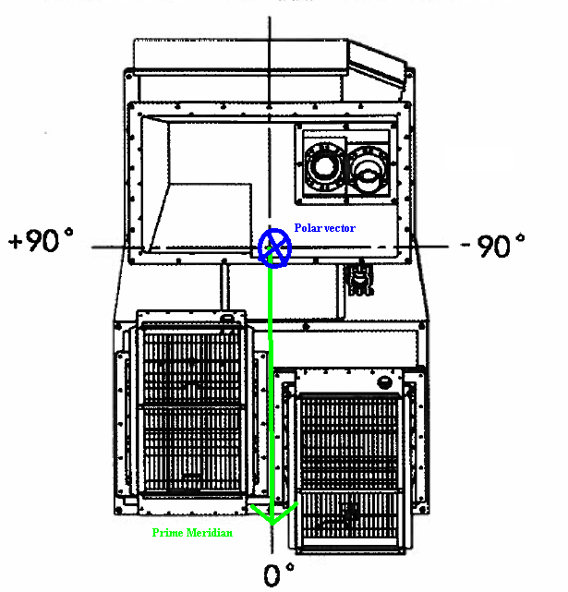
Figure 1: LIGHT Structure Attitude Vectors
The vectors contained in the LIGHT structure go straight into the skymap code which produces the geophysical images. In an effort to produce an image that made geophysical sense, but also retained some of the actuation information within the image, the Azimuthal attitude vector needed to be rotated by -90 degrees about the polar vector to create a vector that pointed in the 0 degree actuation direction. The polar vector did not need to be modified to fit into the skymap format.

