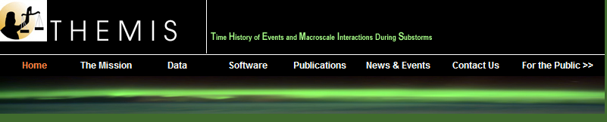

ESA Level 2 Data Processing History

This web page contains significant dates for changes in the software and mastercdfs that are used to create THEMIS Level 2 data files for the ESA (Electrostatic Analyzer) instrument.
Dates for reprocessing of ESA L2 files are included.

Files thx_l2_esa_yyyymmdd_v01.cdf (where x = a,b,c,d or e):

Processing Comments
Date
2007-06-15: ESA L2 files contain full, reduced and burst energy flux spectrograms.
2007-09-11: Reprocessed all L2 files to clean out bad files. No change in ESA variables.
2007-09-17: Version of thm_l2gen_esa that handles cases where only some ESA L0 packet data is present,
and clears ESA common blocks before processing. ESA L2 files are reprocessed.
2007-11-07: All L2 files reprocessed due to changes in L1 state files which use improved spin calculations.
2007-11-15: New version of thm_l2gen_esa, includes calculation of all moments, densities, temperatures and
pressures. Reprocessed all ESA L2 files.
2007-12-19: Full reprocessing of ESA L2 files, to account for a 30% discrepancy in calibration that
Jim McFadden found and fixed at the end of November. Also includes a correction for spacecraft
potential which now comes from the on-board moments file.
2008-01-10: Full L2 reprocessing. No changes in variables or file format.
2008-04-18: Full L2 reprocessing for TDAS version 4.00 QA. No changes in variables, but metadata have been
substantially "beefed up", with new CATDESC tags and plot labels.
2008-05-20: Boom deployment checks added into ESA files, ESA L2 files are reprocessed so that moments are
not present pre-boom-deployment.
2008-06-20: Added sc_pot_source variable and attribute to ESA L2 mastercdfs. Ion moments are now included
in pre-boom-deployment files with spacecraft potential set to 0 for calculation.
2008-07-03: Reprocessed all ESA L2 files due to changes in spacecraft potential calculations.
2008-11-04: Reprocessed ESA to add data quality flags, virtual variables and software version number.
2009-06-30: Reprocessed ESA L2 files due to incorrect processing of 88X15 solar wind electron full mode, for
THEMIS-A from 2009-02-02, for THEMIS-B from 2009-02-17, for THEMIS-C from 2009-02-18,
for THEMIS-D and E from 2009-02-13.
2009-08-25: Full ESA L2 reprocessing, to add quality flags for solar wind while not in solar wind mode, density
mismatches, and counter saturation.

