4.3.3 Error sources and data quality flags

As discussed in above, EFW actively biased the sensors to significantly reduce the sheath impedance, allowing a more stable sensor operation and the measurement of high quality electric fields. However, there remain times when the measurement accuracy of the quasi-static electric field (~<200 Hz when the sensors are resistively coupled to the plasma) decreases. For example, excessive spacecraft charging caused by enhanced fluxes of energetic electrons may make quasi-static data unreliable. Therefore, EFW provides flags allowing the user to ascertain data quality. To specify the quality of the DC electric field data and associated error source, EFW defines 25 flag quantities in the L3 CDF files. The key information about the flags are summarized in Table 4.5. End users should refer to the meaning of these flags when there is a potential need for analyzing the flagged DC-coupled electric field data. A detailed description of each flag is documented at https://spdf.gsfc.nasa.gov/pub/data/rbsp/documents/efw/.

Table 4.5. The 25 EFW flag values in the variable “flags_all” in the L3 data files.
No | Flag name | Conditions for flag=1, which marks questionable data
1 | global_flag | When any of the following flags are thrown: v[1-4]_saturation, eclipse, maneuver, charging, charging_extreme, efw_deploy, efw_sweep, boomflag[1-4]
2 | eclipse | When the spacecraft is in the shadow of the earth, including umbra and penumbra
3 | maneuver | Maneuvering and thrusting
4 | efw_sweep | EFW sensor diagnostic tests (SDT), also known as the bias sweeps
5 | efw_deploy | Boom deploy times early in the mission (2012)
6-11 | v[1-6]_saturation | v1_saturation is 1 when the single-ended probe potential V1 >195 volts (sensor relative to sc potential). v[2-6]_saturation are similarly defined for V2, V3, …, V6
12 | Espb_magnitude | Not used
13 | Eparallel_magnitude | Not used
14 | magnetic_wake | When the wake effect is likely
15 | autobias | When the autobias algorithm is operating
16 | charging | When [L>4 and Vsc > 0 V] or [Vsc<-20 V for any L], where Vsc is the spacecraft potential
17 | charging_extreme | [L>4 and Vsc > 20 V] or [Vsc<-20 V for any L].
18 | density | When global_flag=1 and when density is <10 or >3,000 cm⁻³
19-24 | boomflag[1-6] | boomflag1 is 1 when V1 deviates from the median of [V1,V2,V3,V4] by >5 V. boomflag[2-4] are similarly defined for V2, V3, V4. boomflag[5-6] are not used
25 | undefined | Not used

A.1 Detailed description of error flags
A.1.1 Global flag
The global flag is a general data quality indicator for DC E field measurement. It is an amalgamation of flags that strongly suggests data of bad or significantly reduced quality that should NOT be used. Specifically, the global flag is triggered by any of the following conditions: excessive sensor charging (v[1-6]_saturation, charging, charging_extreme, eclipse, and boomflag[1-4]), sensor diagnostic tests (efw_sweep), attitude changes (maneuver), and antenna deployments (efw_deploy). The relevant flags, as noted in the parenthesis, are discussed in detail below. Globally flagged data are removed in EFW L3 files (which contain spin period cadence data) but remain in the L2 files. Note that it is often the case that AC-coupled EFW data beyond a few hundred Hz, which reside in the L2 filter bank and specral files, may still be usable when the global flag is triggered.

A.1.2 Flags related to sensor diagnostic tests (efw_sweep)
As discussed in section 4, accurate measurements of electric fields in low density plasmas require active biasing in order to control photoemission and limit excessive spacecraft charging. On EFW, photoemission is controlled by current biasing the sensors and voltage biasing the usher and guard surfaces. The ideal bias currents and voltages changed over the course of the mission as the sensors aged and as the orbit precessed. Determining these ideal values therefore required EFW to perform occasional sensor diagnostic tests (SDTs, or bias sweeps) throughout the mission. During SDTs, which lasted a few to tens of minutes, the EFW instrument was stepped through a variety of preprogrammed current and voltage values. All SDT times are flagged with the efw_sweep flag and trigger the global flag.

A.1.3 Flags related to excessive sensor charging
There were times when excessive spacecraft charging could not be avoided. A clear example occurred during a 2012-11-14 geomagnetic storm, shown in Figure A1. An influx of energetic (tens of keV) electrons during the first apogee caused the Van Allen Probe B spacecraft body (with its much larger surface area than the sensors) to charge negatively to -150 volts relative to the sensors, which were biased to be near the plasma potential. This is shown as positive excursions in panel (d) which plots the sensor 1 potential minus the spacecraft potential. This excessive charging reduced the dynamic range of the sensor preamps. When this potential exceeded the rail voltage of 225 volts the preamp could no longer drive the signal and negative dropouts occurred, as shown most prominently from ~03:00-03:30 UT. Importantly, these times of extreme charging led to unrealistically large electric fields.

This type of charging can be separated from the more typical potential fluctuations that occur along the Van Allen Probe orbit (e.g. the second apogee pass on this day) by comparison with HOPE low energy ion fluxes (panel e), which are modified by spacecraft charging (e.g. Sarno-Smith et al., 2016). The clear dropout during the charging event occurred because protons at those energies were accelerated by the negatively charged spacecraft to energies greater than the spacecraft potential.

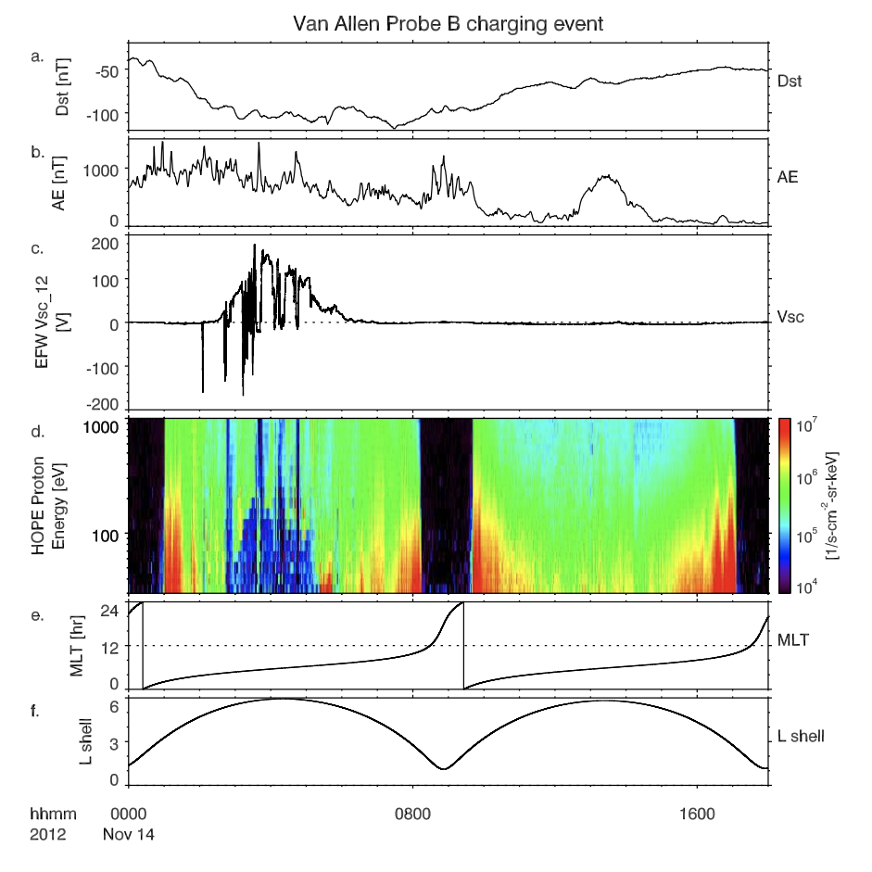
Figure A1 Van Allen Probe B charging during the 2012-11-14 geomagnetic storm. Panels (a,b): DST and AE indices. Panel (c):* EFW electric field as determined by the V₁-V₂ sensor pair. Panel (d): EFW sensor minus spacecraft potential. Panel (e): HOPE proton energy spectrum. Panels (f,g): magnetic local time and L-shell of Van Allen Probe B.
V[1-6]_saturation
To track times of excessive charging, each probe has its own flag (V[1-6]_saturation). The flag is 1 when V_{i} >195 volts. If any of these flags correspond to a sensor used to produce spin-fit data then the global flag is triggered. For example, if the spin-fit data is derived from the V₁ and V₂ probes, then the global flag will only be triggered if excessive charging occurs in V₁ and/or V₂.

Charging and extreme charging flags
In order to identify all times when excessive charging occurred, two additional, more restrictive, charging flags are used, and both trigger the global flag. A general charging flag is used to indicate times when the average of opposing antenna sensor pairs (e.g. (V_{i}+V_{j})/2) satisfies the following conditions: (V_{i}+V_{j})/2 > 0 volts at L>4. This flag was designed to identify less extreme charging events where data quality may still be compromised. For example, the sensors are particularly susceptible to potential fluctuations during magnetosheath encounters due to extremely low density. An additional extreme charging flag is triggered when (V_{i}+V_{j})/2 > 20 volts at L>4, or where (V_{i}+V_{j})/2 < -20 volts. L<4 data are only flagged by the V[1-6]_saturation flag. Extreme charging was more common in the early mission when the sensors were more heavily biased and there were a number of significant geomagnetic storms. The negative value trigger is in place to catch times of saturation when the sensor potentials can drop to the rail values (see negative spikes in Figure A1). As the names suggest, caution and/or extreme caution should be used when examining data during these times. All charging events are flagged within +/- 10 min of onset/offset.

Eclipse flag
The eclipse flag is also related to spacecraft charging. During eclipse (both umbra and penumbra) the spacecraft tends to charge to large negative potentials due to the lack of photoemission. Due to the difficulty of controlling these potentials, EFW did not attempt to maintain sensor potentials near the plasma potential with biasing, but allowed them to float relative to the plasma.

Boom flags
In addition to monitoring the charging status of each boom using the charging and extreme charging flags, we also consider whether all the single-ended potentials are consistent with each other. The consistency is quantified using V_median, which is the median value of V₁, V₂, V₃, and V₄. The boomflags are 1 when the absolute value of |V_{i}-V_{median}| > 5 volts. The threshold of 5 volts is chosen empirically based on a comprehensive analysis of the entire spin-fit dataset. The flags boomflag5 and boomflag6 are not used. This metric not only effectively flags problematic spin-fit electric fields, but also has been used in selecting the best probe pair for calculating the spin-fit electric field.

A.1.4 Flags related to maneuvers, deployments

Maneuver flag
There are a number of data quality issues associated with spacecraft acceleration events including maneuvers and attitude adjustments. Maneuvers, related to orbit change or collision avoidance, occurred only a handful of times. Attitude adjustments were more frequent, occurring roughly once per month in order to keep the spacecraft spin axis in its near sun-pointing direction. Electric field data can be significantly compromised during and for some time after these events and are flagged with the maneuvers flag. Decreased quality occurs during the maneuver and for a short time after due to any plasma plume created by thruster firings, and due to uncertainties in the attitude solution during and after the maneuver. Note that small amplitude oscillations of the booms following a maneuver (not independently flagged) were often detectable for days following a maneuver and can present an issue for data analysis requiring very high accuracy quasi-static electric fields (e.g. Ali et al., 2016).

EFW_deploy flag
Early in the mission, antenna deployments occurred frequently as the sensors, with their large moment of inertia, were carefully deployed in stages. These times are flagged with the EFW_deploy flag. All spin-plane booms reached full deployment on both spacecraft on Sept 22, 2012, and all axial booms reached full deployment on Jan 7th, 2012. All L2 and L3 EFW data products make use of the proper antenna length after each deployment.

A.1.5 Flags related to other data quality issues
We have discussed the flags that trigger the global flag in A.1.1 through A.1.4. From this and later sections, we discuss other flags that do NOT trigger the global flag but are important in evaluating the data quality of the EFW data products.

Autobias flag
Following a flight software update on March 19, 2014, an auto biasing scheme was introduced that allowed automated onboard control of bias currents based on the measured spacecraft potential (V12). This dynamic approach was designed to maximize sensor sensitivity over the wide range of densities and temperatures encountered over an orbit. This scheme, with times indicated by the autobias flag, was used on RBSP-B for the remainder of the mission, and on RBSP-A until shortly after Oct 2015 when V1 performance degraded. Note that the autobias flag does not trigger the global flag because the autobiasing routine typically improves data quality. The flag is saved to evaluate the performance of the autobias algorithm.

Wake effect (magnetic_wake flag)
Historically, a common error source present in double probe measurements are wake effects (e.g. Engwall et al., 2006). These are observed (typically in low densities) when fast (supersonic) plasm flowing to downstream sensors is shielded by the large Debye sheath surrounding the spacecraft body [Bauer et al., 1983; Pedersen et al., 1984; Eriksson et al., 2006]. Wake effects manifest as spin period distortions of the sensor potential (V = Vp - Vsc), as shown in Figure A.2. Wake effects in EFW data are typically small (<1-2 mV/m) due to the long boom lengths and antenna orientation. This error field can, however, be a significant fraction of the total electric field at times when the real electric fields are small (e.g. <5 mV/m). As an example, the red curve in the figure shows a ~1 mV/m zero-peak real (wake-corrected) electric field that appears as a ~1.5 mV/m electric field with the wake effect.

Wake effects are flagged with the magnetic_wake flag with a wavelet analysis to identify
elevated power at harmonics of the spacecraft spin period (panel b). Specifically, peaks are detected over 10 spin periods as power enhancements in both Eu and Ev (spin plane components) at spin period harmonics of 2, 3, and 4. Triggering of the wake flag requires simultaneous wake identification on both Eu and Ev. Because the boom response to wakes of various strengths is complex, the flag for wake effect does not trigger the global flag. However, users are strongly encouraged to be cautious using data when this flag is on. The overall flag is saved as the magnetic_wake flag in the flags data product.

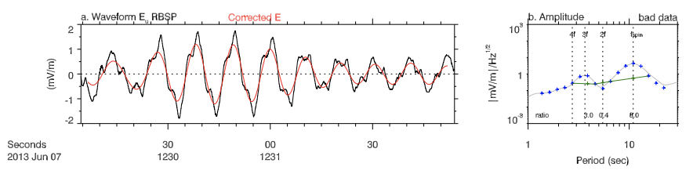
Figure A2 Wake effects and their removal.

Density flag
A final flag related to sensor charging is the density flag. A very useful feature of EFW is the determination of plasma density from sensor potentials at a high cadence (16 S/sec). However, the calibration procedure that converts sensor potentials to density relies on the assumption that the spacecraft potential is driven by a cold plasma population. This can be violated when the global_flag is triggered. In addition, the sensor density is only weakly dependent on the sensor potential for very tenuous plasmas. EFW thus flags density values when the density is determined to be < 10 cm⁻³. Values >3000 cm⁻³ are also considered suspect and are removed. Note that it is often the case that density < 10 cm⁻³ values can be accurate, but careful analysis is required to determine when this is the case. Users should also take care when using EFW-determined density values during times of large electric field amplitudes. For example, Malaspina et al. (2014a) showed that large electric fields can modify the spacecraft surface potential in a way that can erroneously be interpreted as caused by density fluctuations.

$\vec{E}⋅\vec{B}=0$ assumption (spinaxis_Bo_angle)
Data quality is dependent on the magnetic field direction relative to the spin plane for data products that use the $\vec{E}⋅\vec{B}=0$ assumption. When the angle between any of the spin plane directions and the magnetic field is less than ~15 deg, there is significant uncertainty in the calculation. These times are flagged with the variable spinaxis_Bo_angle and the spin-axis derived data are removed.

