Laboratory for Atmospheric and Space Physics

University of Colorado
Boulder, Colorado

Aeronomy of Ice in the Mesosphere
(AIM)
Cosmic Dust Experiment
(CDE)

Algorithm Theoretical Basis Document
(Draft)

Document No. CDE-T-07202 Date: October 19, 2004

Prepared by David James Date _________

Approved by Date _________

Approved by Date _________

Approved by Date _________

Approved by Date _________

Revisions
Rev | Description of Change | By | Approved | Date
A

Contents

1 Introduction 5
1.1 Purpose of this Document 5
1.2 Scope 5
1.3 Applicable Documents 5
1.4 Contributing Authors 6
2 Overview and Background Information 6
2.1 Introduction 6
2.2 Science and Mission Goals and Objectives 6
2.3 CDE Instrument 7
2.3.1 Objectives 7
2.3.2 Instrument Characteristics 7
2.4 Heritage 8
2.4.1 Instrumentation 8
2.4.2 Science Data Production 9
3 Algorithm Description 9
3.1 Theoretical Description 9
3.1.1 Physics of the Problem 9
3.1.2 Conversion from Raw Data to Mass 9
3.1.2.1 Number of Electrons (Level 1 Data) 9
3.1.2.2 Particle Mass (Level 2 Data) 10
3.1.2.3 Particle Influx in Sun-Referenced Space (Level 3 Data) 10
3.1.2.4 10
3.1.3 Uncertainty Estimates (error analysis) 10
3.2 Practical Algorithm Considerations 11
3.2.1 Numerical Computation Considerations 11
3.2.2 Programming / Procedural Considerations 11
3.2.3 Exception Handling 11
4 Calibration, Validation, and Constraints 11
4.1 Calibration 11
4.1.1 Absolute (pre-flight ) Calibration Plan 11
4.1.1.1 Unit Level Calibrations 12
4.1.1.2 System Level Calibrations 13
4.1.2 Relative (In-flight) Calibrations 13
4.2 Validation 13
4.2.1 General Discussion 13
4.2.2 Confidence in Measurements 13
4.2.3 Comparison With Other Cosmic Dust Measurements 14
4.2.4 Validation of CDE Data Against Models of Dust Influx 14
4.2.5 Quality Control and Diagnostics 14
4.2.5.1 Pre-Flight 14
4.2.5.2 In-Flight 14
4.3 Constraints, Limitations, Assumptions 14
4.3.1 South Atlantic Anomaly 14
4.3.2 Orbital Debris 14
4.3.3 Microphonics 15
Appendix A Data Product Requirements and Descriptions 15
CDE Data Level Definitions 15
Appendix B Acronyms 16

List of Figures

Figure 1: Exploded view of detector panel and support feet. 8
Figure 2: Analog Electronics 9
Figure 3: Digital Board Electronics. 10
Figure 4: Sample calibration curve for 30 ºC box temperature, and 6.8 nF detector capacitance corresponding to -100 ºC detector temperature. 13
Figure 5: Calibration diagram including electrical wiring for charge injection circuit. 14
Figure 6: Summary of calibration data reduction. 15

List of Tables

Table 1: Related LASP Documents 5
Table 2: Related SDC Documents 5

Introduction

Purpose of this Document
This Algorithm Theoretical Basis Document (ATBD) describes the algorithms used to produce all data levels for the Cosmic Dust Experiment’s measurement for the mass distribution of incoming particles. This document provides the scientific motivation and goal of the CDE mission, a brief introduction to the instrument and a detailed discussion of the theoretical and mathematical algorithms utilized in the production of scientific results. It is not designed to serve as the only reference to the CDE instrument, data and its algorithms. Other documents will be generated to explain, in much greater detail than presented here, instrument design and operation, instrument calibration, and the ground data system. These related documents should be consulted to complement the information contained here.

Scope
This document describes those algorithms required to generate particle mass distribution from digital number packet received through ground software. The appendices attached to this document provide a more detailed description of the content and format of the CDE data products. The algorithms are described as they are known during the design phase of the instruments and through heritage with SDC. Future changes in instrument design and results of laboratory calibration and testing may incur modifications to parts of certain algorithms.

Applicable Documents
A number of documents presently exist or are being developed to complement this ATBD and are listed below:
Table 1: Related LASP Documents
AIM Mission Requirements Document (MRD): Rev B | Doc. # AIM-T-0100
AIM Instrument Requirements Traceability Matrix | Doc. # TBD
AIM Contamination Control Document | Doc. # TBD
AIM Operations Concept Document | Doc. # AIM-T-0400
AIM Product Assurance Implementation Plan  AIM Project Data Center Software Design Document  AIM Data Management Plan  AIM Science Data Systems Interface Control Document | Doc. # TBD  Doc. # AIM-PDC-SDD-03-1-V0  Doc. # AIM-DMP-03-2-V0  Doc. # AIM-SDS-ICD-03-1-V0

Table 2: Related SDC Documents
CDE Calibration Test Procedure | Doc. # CDE-T-02200

Contributing Authors
Mihaly Horanyi | Principal Investigator
David James | Data Analysis
Beth Grogan | Software Programming
Gail Tate | Software Programming
Vaughn Hoxie | CDE Electrical Engineer
Christopher K. Pankratz | Ground System Manager
Cindy Russell | Science Data Systems Development Co Manager

Overview and Background Information

Introduction
The overall goal of the Aeronomy of Ice in the Mesosphere (AIM) experiment is to resolve why PMCs form and why they vary. By measuring PMCs and the thermal, chemical and dynamical environment in which they form, we will quantify the connection between these clouds and the meteorology of the polar mesosphere. In the end, this will provide the basis for study of long-term variability in the mesospheric climate and its relationship to global change. The results of AIM will be a rigorous validation of predictive models that can reliably use past PMC changes and present trends as indicators of global change.
In order to achieve the science objectives, the mission requires a complement of science instruments to measure the occurrence rates and geographical distribution of PMCs, the size distribution of PMC particles, cosmic dust influx to the atmosphere and precise, vertical profile measurements of temperature, H₂0, CH4, O₃, CO₂, NO, and aerosols. Also required is a spacecraft bus to provide power, pointing, command and data handling, bulk memory, and communications with the ground stations, a launch vehicle capable of placing the spacecraft in the appropriate orbit, mission operations and data processing and distribution.
The AIM mission consists of three instruments: SOFIE (Solar Occultation for Ice Experiment); CIPS (Cloud Imaging and Particle Size experiment); and CDE (Cosmic Dust Experiment). SOFIE is an 8-channel infrared solar occultation differential absorption radiometer that measures temperatures, PMCs, H₂O, CO₂, CH₄, NO, O₃, and aerosols. CIPS is a panoramic UV nadir imager that provides PMC images and particle property information. CDE is an in-situ dust detector that measures cosmic dust input, which is a potential key factor in PMC formation.

Science and Mission Goals and Objectives
The overall goal of AIM mission is to understand noctilucent clouds. This includes the mission goals and science objectives listed below.

The Mission Goals of AIM:
- Resolve why PMCs form and how and why they vary.
- Quantify the connection between these clouds and the meteorology of the polar mesosphere by measuring the thermal, chemical and dynamical environment in which PMCs form.
- Provide the basis for study of long-term variability in the mesospheric climate and its relationship to global change.

The Science Objectives of AIM:
- Determine the global morphology of PMC particle size, occurrence frequency, and dependence upon water and temperature.
- Answer whether gravity waves enhance PMC formation by perturbing the required temperature for condensation and nucleation.
- Determine if dynamical variability controls the length of the cold summer mesopause season, its latitudinal extent and possible inter-hemispheric asymmetry.
- Provide the relative roles of gas phase chemistry, condensation, sublimation, and dynamics in determining the variability of water in the polar mesosphere.
- Determine whether PMC formation is controlled solely by changes in the frost point, or if extraterrestrial forcing such as cosmic dust influx or ionization sources play a role.

CDE Instrument

Objectives
The purpose of CDE is to determine a relation between influx of particles into Earth’s atmosphere and formation of Noctilucent clouds. The link from CDE measurements to cosmic dust supplied cloud nuclei will be established in two ways: 1) immediate transport from Low Earth Orbit (LEO) to the mesosphere, where “smoke” particles have moderate lifetimes; and 2) the assumption that by measuring the small end of the size distribution, the entire dust flux can be measured.
Incoming dust particles pass through the region of S/C altitude to the mesosphere without any significant change in velocity or mass until they reach an altitude of ~100 km. Here the particles ablate and deposit most of their mass in the region of 80-100 km. The material then recondenses into nm-sized “smoke” particles that can serve as nuclei for water condensation and hence control the efficiency of PMC formation. The lifetime of nm-sized smoke particles against coagulation and subsequent removal from the mesopause region is short (~1 week) compared with a PMC season. Thus, the availability of smoke particles as nucleation sites in the mesosphere can be monitored in LEO and correlated to PMC appearances.
The cosmic dust input into our atmosphere is about 100 metric tons per day (Love and Brownlee, 1993). Much of the mass is delivered in the form of 100 µm radius “Zodiacal light” grains. The average flux of these particles as measured on the Long Duration Exposure Facility (Love and Brownlee, 1993) is on the order of 100/m²/yr; however, the flux of smaller grains is expected to be significantly higher. The expected impact rate of 1 µm radius grains is between 10-100/day. We assume that during periods of high dust input rates the fluxes are elevated for all sizes, so that by monitoring the lowest end of the dust size distribution we will monitor the total dust influx as well. The scale-height of the Zodiacal dust cloud is many orders of magnitude larger than the radius of the Earth. During periods of high dust influx an entire hemisphere will be exposed and daily averages of the impact rates can be used to increase statistics.

Instrument Characteristics
CDE consists of three individual parts used to detect cosmic dust. These are the detector panel, the front end analog electronics, and the digital interface electronics.
- The detector panel includes the 14 PVDF detectors and support. A total detection area of 0.082 [m²] is realized with twelve, 13.0 [cm] x 5.2 [cm] individual detectors (two of the fourteen will act as reference and will play no role in detection). The detectors make use of the permanent polarization of the PVDF film for detection. Aluminum nickel layers are deposited on both sides of the PVDF for electrical conductivity and electrodes are attached. A dust impact will create a crater in the PVDF removing dipoles along the path of the trajectory thus creating a fast electric charge pulse without requiring a bias voltage.
Twelve Active Detectors
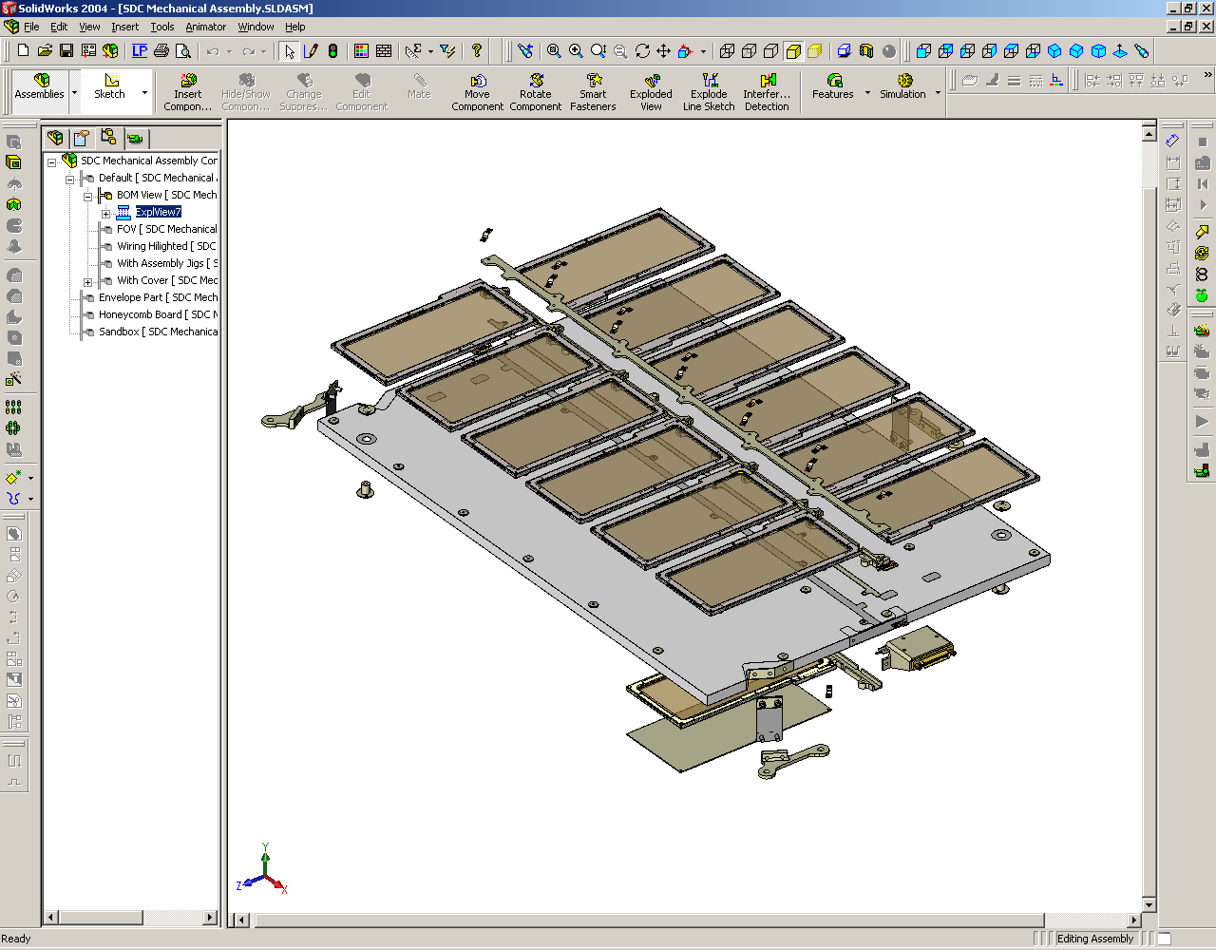
One of Two Reference Detectos
Support Feet
37 Pin Glenair Connector
Figure 1: Exploded view of detector panel and support feet.
- The front-end electronics for each detector channel consists of an analog preamplifier and a shaping circuit. The preamplifier is a discrete component charge sensitive amplifier with a JFET input stage. The IF3601 input JFET manufactured by InterFET Corporation is specially designed for large capacitance detectors. The shaping circuit is a 2 stage 2nd order band-pass circuit with its corner frequency set to a minimum of 1/f and component noise. Following the shaping circuit a peak hold circuit holds the signal for sampling by a FPGA driven ADC.
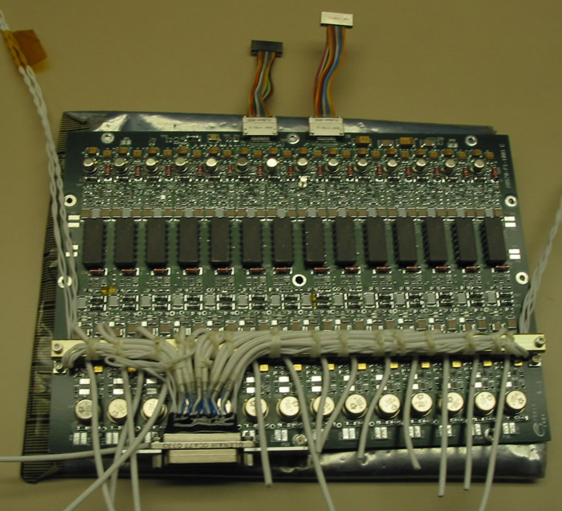
Figure 2: Analog Electronics
- The digital interface electronics provide the interface between the spacecraft C&DH system and the CDE. They are built around a radiation hardened Atmel 80C32E microprocessor and an Actel 54SX FPGA. The FPGA controls sampling of the 14 analog channels and event detection while the microprocessor handles data logging and communication with the spacecraft through the CIPS RS422 interface.
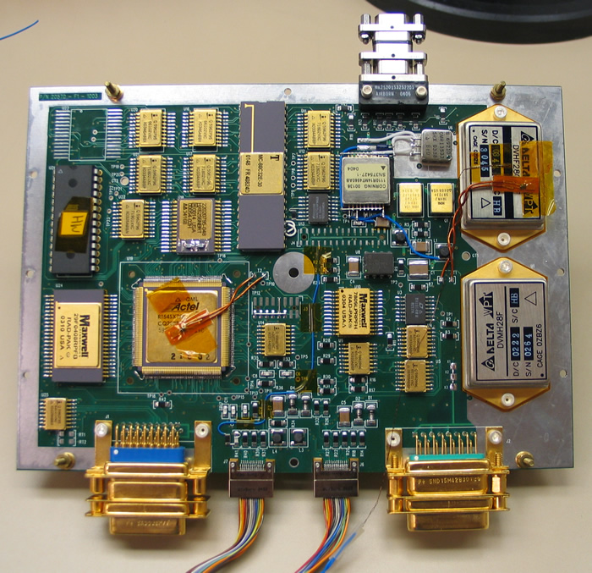
Figure 3: Digital Board Electronics.
The total mass of CDE will be less than 1.3 [kg]. The power consumption will not exceed 2.5 [W],. The total volume will be less than 40 x 40 x 3 [cm³]. CDE shall not exceed 0.1 MB per orbit, and will be able to survive in the temperature range of -40 - +50 ºC.

Heritage

Instrumentation
CDE design builds on technology demonstrated in the successful VEGA 1 and 2, STARDUST, CASSINI, and ARGOS missions. CDE inherits its mechanical, electrical and software designs from SDC. Through SDC the design and technology has been tested and improved upon.

Science Data Production
LASP software engineers have extensive experience with modern object-oriented software engineering practices, methodologies, and tools, as well as with state-of-the-art scientific, numerical, and astronomical software libraries and packages. CDE processing software will consist of reusable algorithms and code already developed for another LASP project (SDC on NEW HORIZONS).

Algorithm Description

Theoretical Description

Physics of the Problem
The detectors consist of a layer of permanently polarized PVDF film between two thin layers of aluminum/nickel alloy. The permanently polarized PVDF film will depolarize in the local region of a particle impact. This causes a current to flow dependent on the velocity and size of the particle. Since the velocity of the particles is the terminal velocity of incoming particles and is a known constant, determination of the amplitude of the current can be used to calculate particle size.

Conversion from Raw Data to Mass
Raw science and housekeeping telemetry will be stored at LASP. From this we can get channel number, signal amplitude, box temperature, detector temperature, threshold, and time. The objective of CDE is to convert signal amplitude to mass of a particle as a function of space and time. From the time, the position of the satellite (and hence the particle’s position) is determined. From calibration procedures (outlined in section 4.1) particle mass can be calculated to give results as a function of space and time.

Number of Electrons (Level 1 Data)
Input Values: Box Temperature(T_{box}), Amplitude (DN), and Channel (c).
Output: Number of Electrons(Q)
From calibration (see 4.1.1.1.2.a) we have a 14 X 6 X 6 array. The first fourteen are for each of the 14 channels. The second 9 are for the polynomial coefficients G_{0…8}. The final 6 are the a and b coefficients used to find the Gaussian coefficients given a temperature T via the equation:
a_{n}T + b_{n} =G_{n}.
There are six a and b values instead of two because the fit is piecewise defined. The first two are a and b for temperatures less than 20 ºC, the second two are for temperatures between 20ºC and 30ºC, and the last two are for temperatures above 30 ºC.
The program to calculate level one data uses the channel number to determine the first element of the matrix. The temperature is then used to determine which a and b coefficients to use. They are then put into the equation a_{n}*T+b_{n}=G_{n} to get the nine G coefficients. Finally these fit coefficients are used in a 9th order polynomial to get the charge (Q).

Particle Mass (Level 2 Data)
Input Values: Velocity (v), Charge (Q)
OutPut: Particle Mass(m)
After finding the number of electrons (Q) associated with the signal through the above process the Simpson-Tuzzolino relation can be used to solve for the mass:
Q = 3.8 * 10¹⁷ m [g] ^{1. 3} * v [km/s] ^{3. 0}
=> m [g] = (Q * 2.63 * 10⁻¹⁸ v [km/s] ^{-3.0} )^{0 . 769}
This equation contains the two variables mass (m) and velocity (v). By taking the velocity to be the escape velocity of the particle plus the satellite velocity we can solve for the mass.

Particle Influx in Sun-Referenced Space (Level 3 Data)
Input: Particle Mass(m), Time(t)
Output: Mass(m), Position(x), Time(t)
The spacecraft time is recorded in the Level 0 data. By relating this to the position the satellite was at for that given time the sun-referenced position is recorded for each event. Since we know the time and the mass for each event we get a temporal/spatial relation to the particle influx.

TBD

Uncertainty Estimates (error analysis)
All calculations which involve physical quantities with uncertainties will incorporate the correct propagation of those uncertainties into the calculated results, on the assumption that the measurement uncertainties are independent. Specifics (TBD)

Practical Algorithm Considerations

Numerical Computation Considerations
The CDE algorithms involve non-linear (but mathematically simple and computationally straightforward) fit routines to interpolate calibration data for all possible variable ranges. The most computationally intensive activities include the frequent noise floor determination from (non-linear) least-squares exponential fit from in-flight calibration data. However preliminary noise data from SDC has been analyzed and a routine has been written to compute thresholds. Simple changes (if any) will be needed to adapt this algorithm to CDE.

Programming / Procedural Considerations
TBD

Exception Handling
TBD

Calibration, Validation, and Constraints

Calibration

Absolute (pre-flight ) Calibration Plan
Calibration curves for each of the 14 channels will be established pre-launch to give us charge input (Q) as a function of signal amplitude (DN), box temperature (T_{box}), and detector temperature (T_{det}) . This will be done for 21 signal amplitudes, 4 box temperatures, and 3 detector temperatures. Interpolation of this data will give calibration curves for intermediate ranges. (See Document # CDE-T-02200)
From this and the terminal velocity of the particle we can use the relation
Q(DN, T_{box}, T_{det}, Channel) = 3.8 * 10¹⁷ m [g] ^{1. 3} * v [km/s] ^{3. 0}
to get particle mass as a function of space and time. Shown below is an example curve for 21 signal amplitudes at one box/detector temperature.
Figure 4: Sample calibration curve for 30 ºC box temperature, and 6.8 nF detector capacitance corresponding to -100 ºC detector temperature.

Unit Level Calibrations
Unit level calibrations include:
- Experiments at the MAX-PLANC-INSTITUT in Heidelberg Germany will be performed on PVDF detectors to verify Simpson-Tuzzolino relation. (Note that that successful verification on identical SDC detectors has already been done.)
- Electronics box calibration is performed at box temperatures of -20, 0, +30, +40 ºC, each for 3 simulated detector capacitances at -100, 0, +25 ºC (represented by 6.8nF, 15nF, and 28nF capacitors). This includes both external injected charges, and internal injected charges.
  - The block diagram of the external injected charge calibration setup is shown in Figure. The function generator puts a voltage across the charge injection box. This produces a current simulating that produced by a dust particle of known size. For this external injected calibration 21 charges at 3 detector temperatures, and 4 box temperatures (see above) were injected for each of the 14 channels 100 times. Fit curves were then created to get Q (DN, T_{b}, channel).
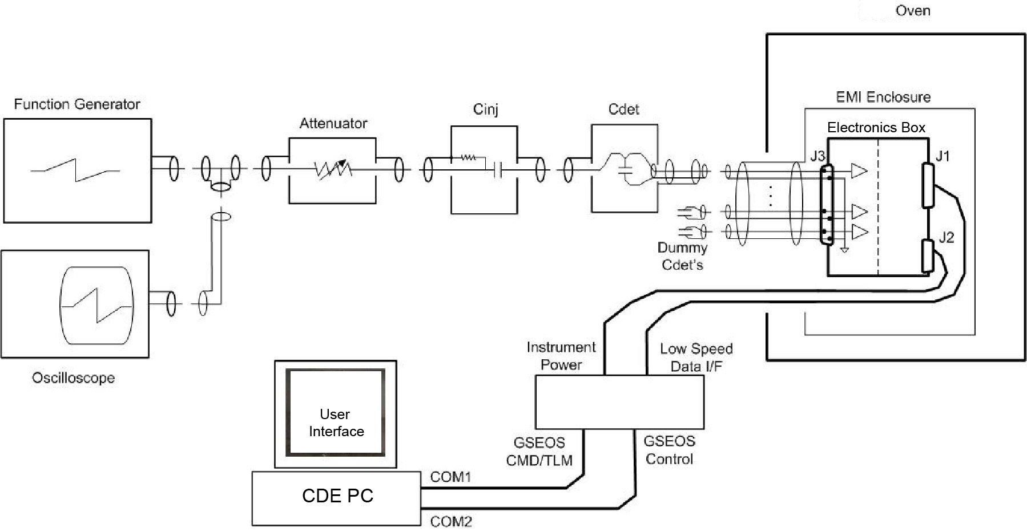
Figure 5: Calibration diagram including electrical wiring for charge injection circuit.

As mentioned above the pre-flight calibration yields an array of data that is 14 X 21 X 4 X 3 X 100. After analyzing the data it was determined that the variance due to different detector temperatures was within our acceptable error for each run (See Figure). Thus data for different detector capacitance values were combined resulting in a 14 X 21 X 4 X 3 X 100 array. For each of the 14 channels the 300 injections are combined to get average charge, DN, standard deviations for DN, and number of points averaged at each box temperature. (Note that the number of points is included because the 300 injections is a nominal number. It is possible to get fewer than 300 data points for any given charge.)
Next, for each box temperature, the 21 points are fit with a 9th order polynomial. This will result in a 14 X 4 X 9 array representing channel, box temperature, and coefficient respectively.
Finally, these coefficients are fit as a function of temperature to give Q (DN, T_{box}). To do this a linear interpolation is used between each measured detector temperature. Fit from negative 20ºC to 0ºC, 0ºC to 30ºC, and from 0ºC to 40ºC. This will yield 9 a and b coefficients. The resulting array is 14 X 6 X 6 array representing channel, polynomial coefficient placeholder, and a, b to determine the polynomial coefficient from temperature. (See Figure 6 for summary of this data reduction and 3.1.2.1 above for using the array in data collection).

nject 21 known charges at 3 different detector temperatures, and 4 different box temperatures for each of the 14 channels 100 times.
Resulting Array is 14 X 21 X 3 X 4 X 100
Combine all of the detector temperature data.
Resulting Array is 14 X 21 X 4 X 300
Combine all 300 points for each channel, box temperature, charge to get average standard deviation, charge, and number of points recorded.
Resulting Array is 14 X 21 X 4 X 4
Fit with a 9th order polynomial to get Q(DN, G_{0…5}) for each channel, box temperature.
Resulting Array is 14 X 4 X 9
Linearly interpolate the coefficients for the various box temperatures for each channel. This way you can get functions G_{n}(T_{box}) where n=0,5 for each channel. Now there exists Q(DN, T_{box})
Resulting Array is 14 X 9 X 6
Figure 6: Summary of calibration data reduction.
  - CDE also has the capability to inject a charge internally. This charge gets injected by the front end of the electronics box to calibrate system level electronics. The purpose of this second injection is to compare to the same measurements in-flight.

System Level Calibrations
Although a thorough system calibration with dust particles is not feasible, a verification of continued unit level status will be checked at the system level with a CPT-L (see sec 4.2.5).

Relative (In-flight) Calibrations
As mentioned in section 4.1.1.1.b CDE has the capability to inject a limited set of charges (8) internally by a command from ground control. From these 8 charges a part of the full calibration curve produced pre-flight will be produced allowing for comparison/change. The calibration charge injections will initially occur twice per orbit. This will both characterize the orbit and be a comparison to the pre-flight calibration. After this has been characterized, charge injections will occur much less frequently (TBD in-flight).

Validation

General Discussion
The validation process is a subset of the both the science analysis and the data quality assurance. The CDE science team oversees this process which involves a careful examination of all impact data and judges the reasonableness and quality of the data. The validation takes two main forms: 1) based on the confidence in the calibration and performance of the instruments, 2) based on comparison with previous and simultaneous measurements from other instruments.

Confidence in Measurements
Through the CDE pre-flight calibrations and characterization, coupled with in-flight characterizations and verification, the instrument scientists will establish a precision and uncertainty to be ascribed to each set of observations (a set being data collected between points of in-flight calibration).
CDE will also make use of two reference detectors included on the back side of the panel which are covered to prevent impacts. Any noise created from the satellite or other large scale anomalies should be registered on the reference detectors and can be corrected for.

Comparison With Other Cosmic Dust Measurements
The CDE data will be compared to other cosmic dust measurements. LDEF has some (348 days) time resolved data for particle flux but was unable to distinguish between orbital debris and cosmic dust (see 4.3.2). SPADUS uses detection methods similar to CDE and should have 3 year data for particle flux. Although discrepancies may occur due to temporal differences, LDEF and SPADUS will provide a reference for earth incident dust.
The SDC mission to Pluto and the Kuiper Belt will provide sensitivity and functionality comparisons. Although differences exist (temperature, speed, dust density, etc.),

Validation of CDE Data Against Models of Dust Influx
TBD

Quality Control and Diagnostics

Pre-Flight
Besides standard flight instrument quality control, CDE can make use of the piezoelectric response of the PVDF films for quality control and diagnostics pre-flight. By exposing the detectors to a short pulse of non-destructive laser light, a signal identical to a dust impact can be produced. Conducting this CPT-L characterizes and verifies performance at the system or detector level. These CPT-L’s will be performed at key points in fabrication, integration, and testing.

In-Flight
The electronics design allows for 8 different known charges to be injected to each channel independently in flight. By using these internal signals we can verify performance throughout the mission.

Constraints, Limitations, Assumptions

South Atlantic Anomaly
The energies of particles due to the SAA are not be large enough to cause a depolarization signal, and since the CDE detectors have their ground side outward facing, any charge incident on the detectors will be dissipated to ground. For these reasons, no special consideration of the South Atlantic Anomaly need be done for the detectors themselves.
Electronics – TBD

Orbital Debris
There are two types of particles that are expected to impact our detector, orbital debris and incoming cosmic dust. To establish a connection to cosmic dust and noctilucent clouds we must either be able to ensure that only incoming cosmic dust is measured, or be able to distinguish between the hits produced by these two types of particles.
Since orbital debris has its greatest velocity component parallel to the direction of motion of the satellite and cosmic dust has its greatest velocity component normal to the direction of motion the problem becomes that of distinguishing between particles incident at glancing angle and those near normal incidence. CDE will point in the zenith direction thus eliminating the vast majority of orbital debris for detection.

Microphonics
TBD

- Data Product Requirements and Descriptions

CDE Data Level Definitions
The CDE science data system will generate data that conforms to the AIM data product levels described in the AIM Science Data Systems Data Management Plan. The data levels are used to refer to the type of data contained in the product. Data levels are adapted by AIM from the EOS Handbook.

Raw Telemetry | Unprocessed digital telemetry
Level 0 | Unprocessed instrument telemetry data. This will be in the form of a digital number representing amplitude, threshold, panel temperature, box temperature, channel ID number, housekeeping data and time stamp. There will be one set of this data for each event recorded. Level 0 data will be available immediately after commissioning CDE and will be produced daily.
Level 1 | The CDE amplitude (in DN) will be converted to charge (in number of electrons). This will be done via the calibration curves established pre-launch. The result will be CDE amplitude for each event in units of charge (Q_{e}). Level 1 data will be available immediately after commissioning CDE and will be produced daily.
Level 2 | Charge will be converted to mass. The mass will be determined using Simpson-Tuzzolino (see sec. 4.1.1)and/or Heidelberg pre-flight calibration. The result will be mass of impacting particle per event. Level 2 data will be available immediately after commissioning CDE and will be produced daily.
Level 3 | Using reference detectors, coincident events will be removed and a noise spectrum will be established. Using this noise corrected time series, total flux and size distribution in sun referenced inertial frame resolving at a minimum, the northern and southern hemispheres will be established. After approximately one month of operation, this Level 3 data will be available on a weekly basis.
Level 4 | Flux and size distribution of cosmic dust particles will be correlated with a CIPS NLC index (TBD). The coefficients from this product will be available after the first NLC season and will be update semi-annually.

- Acronyms
ARGOS | Advanced Research and Global Observation Satellite
ATBD | Algorithm Theoretical Basis Document
CDE | Cosmic Dust Experiment
CIPS | Cloud Imaging and Paritcle Size
CPT-A | Comprehensive Performance Test (Ambient)
CPT-L | Comprehensive Performance Test (Laser)
CU | University of Colorado, Boulder
DN | Digital Number
FET | Field Effect Transistor
FPGA | Field Programmable Gate Array
LASP | Laboratory for Atmospheric and Space Physics
LDEF | Long Duration Exposure Facility
LEO | Low Earth Orbit
MB | Megabyte
PMC | Polar Mesospheric Clouds
PVDF | Polyvinylidene Flouride
SDC | Student Dust Collector
SPADUS | Space Dust and Energetic Particle Experiment

